Outlook Email Not Syncing / Outlook Won’t Open
STEP 1: Check Internet Connection
What the user sees
- Browser does not open websites
- Outlook shows “Trying to connect…”
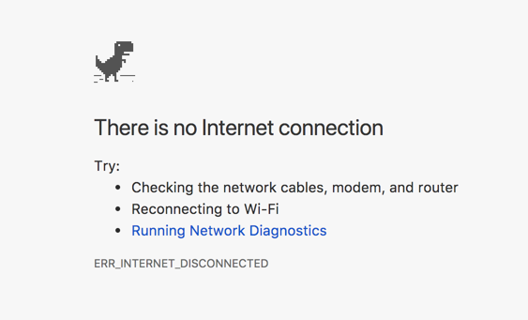
User action (simple):
- Open Chrome or Edge
- Try opening any website
- If not opening → turn Wi-Fi OFF and ON
- Try again after 1 minute

STEP 2: Turn OFF “Work Offline” in Outlook
This is the most common reason emails don’t sync.
User action:
- Open Outlook
- Click Send / Receive
- Click Work Offline (so it is NOT highlighted)
- Wait 1–2 minutes

STEP 3: Restart Outlook from Task Manager
Fixes Outlook freeze / crash.
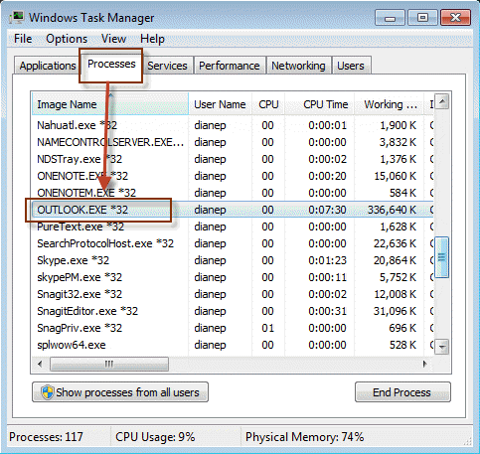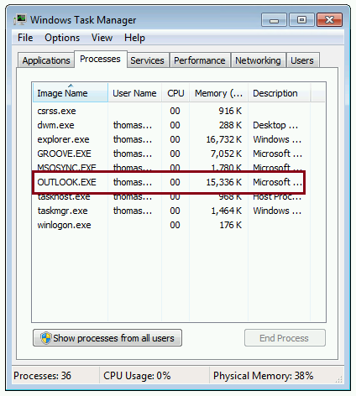
User action:
- Close Outlook
- Press Ctrl + Alt + Delete
- Open Task Manager
- Select Microsoft Outlook
- Click End Task
- Open Outlook again

STEP 4: Open Outlook in Safe Mode
Used when Outlook crashes or won’t open.
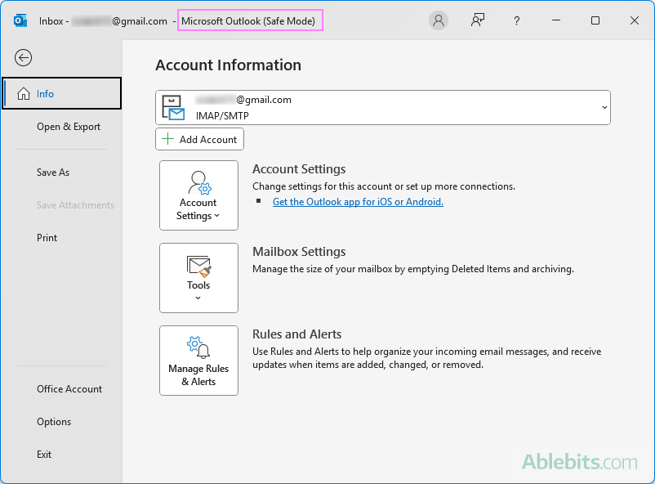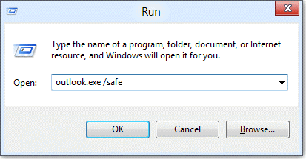
User action:
- Press Windows + R
- Type outlook /safe
- Click OK
- If Outlook opens → close it
- Open Outlook normally

STEP 5: Restart the Computer
Clears stuck background issues.
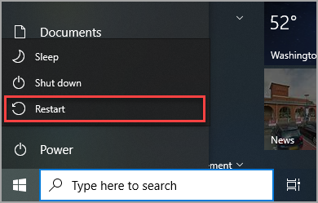
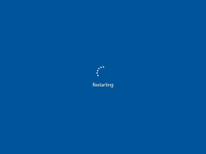
User action:
- Save work
- Restart computer
- Open Outlook
- Wait 2–3 minutes for sync

STEP 6: Check Mailbox Storage (Mailbox Full)
If mailbox is full, emails stop syncing.
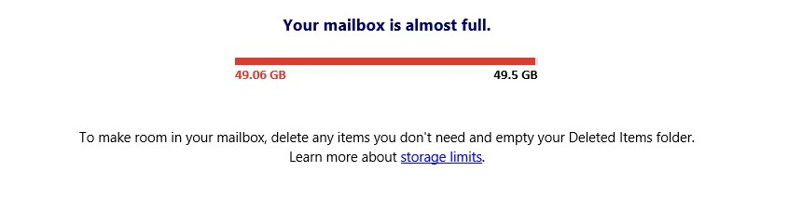
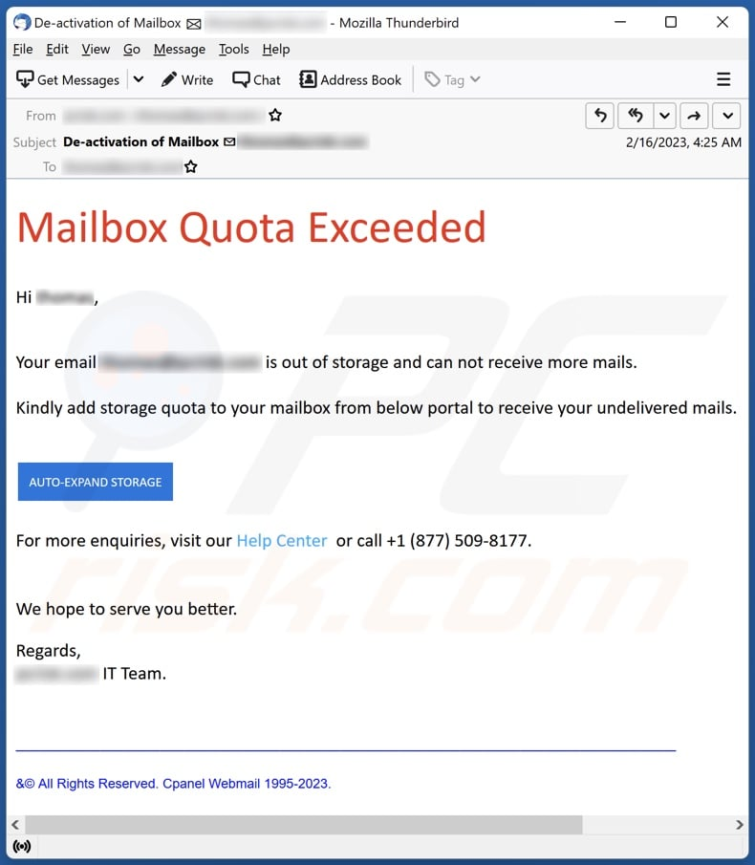
User action:
- Open Outlook Web in browser
- Delete old emails
- Empty Deleted Items
- Wait 10–15 minutes

When to Contact IT Support
Contact IT only if:
- Outlook does not open at all
- Error message keeps repeating
- Issue continues after all steps
Share with IT:
- Screenshot of error (phone photo is fine). When issue started

